MA 677 Final assignment
Chunlin Liu
May 8 2026

Introduction:

One concept that repeatedly appeared throughout MA677 was the idea of approximation in statistical inference. In many situations, statisticians are interested not only in an estimator itself, but also in a nonlinear transformation of that estimator, such as a logarithm, ratio, or square root transformation. While these transformed quantities are often useful in practice, their exact distributions can be difficult or impossible to derive analytically. This led me to become interested in the Delta Method, a technique that uses Taylor series approximations to approximate the distribution of transformed estimators. The topic also connects closely to several themes discussed in MA677, including asymptotic normality, approximation, and the role of mathematical reasoning in statistical inference.

Another reason I chose this topic is that I encountered many situations in other statistics projects where variables were transformed using logarithms before modeling or analysis. Although I understood that log transformations were often used to reduce skewness, stabilize variance, or improve model assumptions, I realized that I did not fully understand how these transformations affected the distribution and uncertainty of estimators. The Delta Method seemed like a useful way to connect these practical transformations to the underlying statistical theory. I was especially interested in understanding why the approximation works, how sample size affects its accuracy, and what limitations arise when the transformation is highly nonlinear or the sample size is small.

Overview of paper:

The paper I decided to use is “A Note on Delta Method” from professor Oehlert.(1992) The paper discusses the Delta Method as a technique for approximating the moments and distributions of functions of random variables when exact calculations are difficult or impossible. Rather than focusing only on the computational formula itself, the paper emphasizes the underlying logic of the approximation and the mathematical conditions under which the approximation is accurate. The paper explains that the Delta Method works by replacing a nonlinear function with a local polynomial approximation, usually a first-order Taylor expansion centered around the mean of the random variable. Oehlert also discusses situations in which the approximation performs well and situations in which it may fail, especially when important moment conditions are violated.

Because the abstract of the paper was extremely short, there are only 2 sentences, I began by reading the introduction section in order to understand the main purpose of the paper and the author’s overall argument. I then focused on the explanations and examples rather than trying to immediately understand every mathematical derivation. This approach helped me first develop an intuitive understanding of what the Delta Method was trying to approximate before concentrating on the technical details. I also reread several sections multiple times, especially the discussion about Taylor series approximations and the conditions required for the approximation to work accurately. The examples in the paper were especially helpful because they showed both successful and unsuccessful uses of the Delta Method. One example demonstrated that the approximation can completely fail when the required moment conditions are not satisfied, even if the approximation initially appears reasonable.

Concepts understood and Question I have:

After reading the paper, I developed a much clearer understanding of the main idea behind the Delta Method and how the approximation is derived mathematically. In particular, I understood that the method uses a Taylor series expansion to locally approximate a nonlinear function with a linear function, which then allows the distribution and variance of a transformed estimator to be approximated more easily. I also understood why derivatives naturally appear in the variance approximation formula and why the approximation generally becomes more accurate as the sample size increases. However, there were still several technical aspects of the paper that I did not fully understand. In particular, I found the discussion of finite moment conditions difficult to interpret intuitively. I understood that the paper repeatedly emphasized the importance of having “enough finite moments” in order for the approximation to remain valid, but I was not completely clear on why the failure of higher-order moments could cause the Delta Method approximation to break down. Although I could follow the general logic of the examples, I still found the connection between moment conditions, convergence, and approximation accuracy mathematically challenging, especially in the examples where the expected value became infinite despite the approximation appearing reasonable at first.

Question brought up from paper:

One question that the paper raised for me was how accurate the Delta Method approximation remains under different sample sizes and different types of nonlinear transformations. Throughout the paper, the approximation was discussed mainly from an asymptotic perspective, meaning that the approximation improves as the sample size becomes large. However, in practical data analysis and machine learning applications, sample sizes are not always sufficiently large, and transformations can sometimes be highly nonlinear. This made me wonder how reliable the approximation actually is in realistic situations. I was especially interested in this question because, in several of my previous statistics and machine learning projects, I encountered situations where variables were transformed using logarithms before modeling. In some projects, log transformations were used to reduce skewness or stabilize variance, while in others they were applied to improve model performance or satisfy modeling assumptions. This paper therefore raised a broader question for me about how approximation methods such as the Delta Method connect theoretical statistical inference with practical modeling decisions in real data analysis.

Try on real data:

As a practical application related to this paper, I revisited a depression prediction project from MA679 that used NHANES data. In that project, I observed that the depression score distribution was strongly right-skewed, with a large concentration of participants having very low or zero scores. After downloading and cleaning the NHANES dataset, I created a total depression score by adding up the score of the DPQ variables and then explored several common transformations, including logarithmic and square-root transformations. Figures here shows the distributions of the original depression score together with the transformed versions.
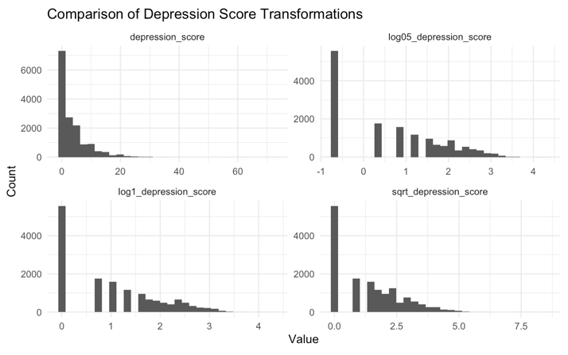

Although the transformed variables remained right-skewed, both the log and square-root transformations reduced the influence of the extreme upper tail and compressed the scale of larger values compared to the original distribution. This exercise helped me better understand an important point related to the Delta Method: the method does not require the original variable itself to follow a perfectly normal distribution. Instead, the approximation is primarily concerned with the asymptotic behavior of estimators and transformed estimators, particularly when the sample size becomes sufficiently large. Working with a real dataset therefore helped me connect the theoretical ideas from the paper to practical modeling situations where transformations improve stability and interpretability even when the resulting distribution is still not perfectly symmetric.

To further explore the Delta Method in practice, I repeatedly sampled observations from the NHANES depression score data using two different sample sizes, n=30 and n=100. For each resampled dataset, I computed the transformed estimator log( bar X + 1), where bar X was the sample mean depression score. I then compared the empirical variance obtained from repeated resampling with the variance approximation predicted by the Delta Method using its formula for calculating variance.

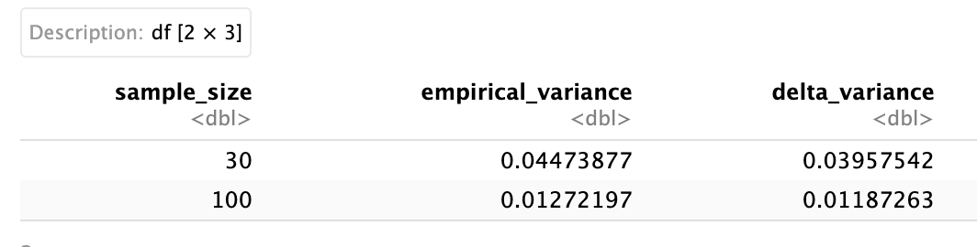
The results showed that the Delta Method approximation was close to the empirical variance for both sample sizes, but the approximation became noticeably more accurate when the sample size increased from 30 to 100. In both cases, the Delta Method slightly underestimated the empirical variance, likely because the first-order Taylor approximation does not fully capture the nonlinear curvature of the logarithmic transformation. Overall, this practice by using real data provided empirical support for the asymptotic behavior of the Delta Method, since the approximation became more accurate as the sample size increased.

Additional resources used:

In addition to the primary reference paper, I used some outside resources to better understand the intuition and derivation of the Delta Method. I watched two YouTube lectures, and I also reviewed Stanford lecture notes on the Delta Method and asymptotic inference, which provided a more formal explanation of the derivation and theoretical background. By using these reference, they helped me better balance conceptual intuition with mathematical understanding. I will add links of these resources at the end of this assignments and GitHub link.

Concepts I taught myself and future plan of study:

This project also changed the way I think about learning statistics independently. I realized that understanding a statistical concept often requires more than simply reading a textbook or research paper once. In practice, I needed to compare multiple explanations, search for outside resources, and test the ideas using real data before the concepts became intuitive to me. Applying the Delta Method to the NHANES depression score data was helpful because it allowed me to connect abstract asymptotic theory to a practical modeling problem.

If I continue studying this topic in the future, I would like to learn more about higher-order Delta Method approximations, multivariate versions of the method, and alternative approaches such as bootstrap inference. I would also like to strengthen my understanding of the mathematical conditions underlying asymptotic approximations, especially the role of finite moments and convergence assumptions. More broadly, this project showed me that self-directed experimentation and practical data analysis are important parts of learning advanced statistical ideas outside the classroom.

AI use disclosure:
AI tools, including ChatGPT, were used in the practical NHANES depression score exploration, including support with coding, and interpretation of the Delta Method variance approximation.

Citation:
Eloriaga, J. (n.d.). The Delta Method. Retrieved from
https://www.youtube.com/watch?v=Tv1pEA8RngE
Caffo, B. (n.d.). MBBC2 lecture06 the delta method. Retrieved from
https://www.youtube.com/watch?v=ZY1o7hXYlaI
Gary W. O. A Note on the Delta Method. Retrieved from
https://www.jstor.org/stable/2684406?utm_source
(N.d.). Retrieved from
https://web.stanford.edu/class/stats200/Lecture17.pdf

